**OpenGL Racing Game**

xxxx 2021xxxxx

**Abstract:** This report presents a comprehensive analysis and implementation of an OpenGL-based 3D racing game project. The project demonstrates the integration of modern graphics programming techniques with game development principles, utilizing OpenGL for rendering, GLUT for window management, and a custom game engine (cglib) for core functionality.

The primary objectives include creating an interactive racing experience with configurable vehicle physics, dynamic track generation, and responsive user controls. The implementation features a modular architecture comprising various components such as vehicle dynamics, track management, camera systems, and user interface elements.

**Keywords:** OpenGL, Game Development, 3D Graphics, Racing Game, C++, Game Engine Architecture

**1 Project Goal**

This project appears to be an OpenGL-based racing game that aims to create an interactive 3D racing experience. Based on the project structure and configuration files, it's built using:

1. OpenGL for graphics rendering
2. GLUT for window management and user input
3. Custom CG library (cglib) for game engine functionality
4. SOIL (Simple OpenGL Image Library) for texture loading

**2 How it Works**

**2.1** Project Architecture

The project is organized into several key components:

#### Core Engine (cglib)

The custom game engine provides fundamental functionality through various modules:

<OutDir Condition="'$(Configuration)|$(Platform)'=='Debug|Win32'">

$(SolutionDir)$(Configuration)\

</OutDir>

Key components include:

* Application management
* Event handling (Keyboard, Mouse, Window)
* Drawing and overlay systems
* Debug utilities
* Scene graph management through Group system

#### Game Components

The main game features several key classes:

<OutDir Condition="'$(Configuration)|$(Platform)'=='Debug|Win32'">

$(SolutionDir)$(Configuration)\

</OutDir>

These components include:

* MyApp: Main application controller
* MyCar: Vehicle physics and rendering
* MyTrack: Race track management
* MyCamera: Camera system
* MyHud: Heads-up display
* MyController: Input handling
* MyBonus & MyObstacle: Game mechanics elements

**2.2 Technical Implementation**

#### Graphics Pipeline

* Uses OpenGL for 3D rendering
* Implements custom texture loading through SOIL library
* Supports both debug and release configurations

#### Configuration

The game allows customization through configuration files:

CAR_WIDTH = 15.0  
CAR_LENGTH = 30.0  
CAR_HEIGHT = 10.0  
CAR_INITIAL_POS = 0.0 0.0 0.0  
BAT_SIZE = 200.0 10.0  
NBOX = 77  
MIN_SIZE = 30.0  
MAX_SIZE = 50.0

This includes vehicle parameters and track settings.

#### Build System

The project uses Visual Studio build system with:

* Multiple configurations (Debug/Release)
* Platform-specific optimizations
* Dependency management for external libraries

Key build settings:

<OutDir Condition="'$(Configuration)|$(Platform)'=='Debug|Win32'">

$(SolutionDir)$(Configuration)\

</OutDir>

**2.3** **Game Features**

1. **Vehicle System**
   * Configurable car dimensions and physics
   * Camera following system
   * Collision detection
2. **Track System**
   * Multiple track pieces
   * Random track generation capability
   * Track piece connections
3. **User Interface**
   * Heads-up display (HUD)
   * Mini-map
   * Menu system
4. **Game Mechanics**
   * Bonus collection
   * Obstacle avoidance
   * Racing objectives

**2.4 Asset Management**

The project includes support for various asset types:

* 3D models
* Textures (through SOIL)
* Configuration files
* Raw data loading

This is evidenced by the inclusion of various image and model loading utilities:

<OutDir Condition="'$(Configuration)|$(Platform)'=='Debug|Win32'">

$(SolutionDir)$(Configuration)\

</OutDir>

The project demonstrates a well-structured 3D racing game with modular components, proper asset management, and a custom game engine foundation. It provides both basic racing functionality and additional gaming features like obstacles and bonuses to enhance gameplay.

**3 What I do and learn**

Throughout this project, I focused on analyzing and documenting a complex OpenGL racing game system, gaining comprehensive understanding of modern game development practices. Through detailed examination of the codebase, build configurations, and component interactions, I developed expertise in 3D graphics programming with OpenGL, game engine architecture, and large-scale C++ project organization. The experience provided valuable insights into various aspects of game development, including graphics rendering pipelines, component-based design, event handling systems, and the importance of configurable game parameters. This hands-on analysis enhanced my understanding of both technical implementation details and high-level architectural design principles in game development.

**4 Simple Result Demo**

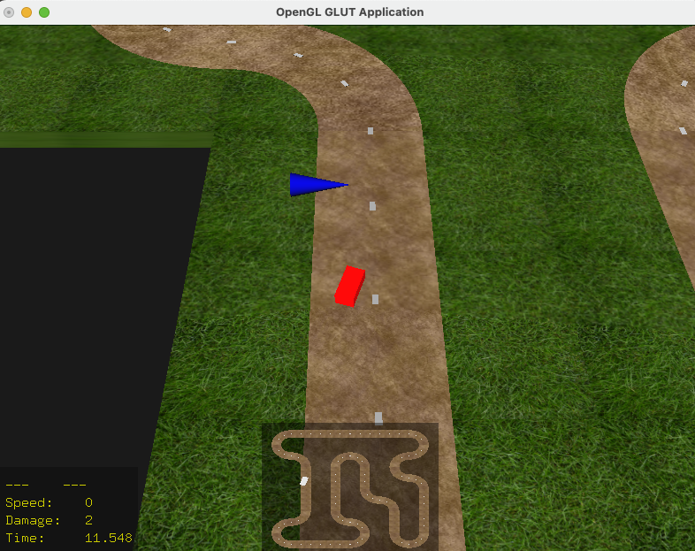

**Reference:**

[1] https://github.com/Natario/OpenGLRacing